Machine Learning Project
Fake Job Posting Detection System
Done by: Dareen Fawwaz

1. Project Overview
Online job platforms have become a primary channel for recruitment; however, they are also increasingly exploited for fraudulent job postings. Fake job advertisements can lead to financial scams, identity theft, and loss of trust in recruitment platforms.
The objective of this project is to build an intelligent machine learning system capable of automatically detecting whether a job posting is real or fake based on its textual content and metadata.
The system is designed to be:
- Accurate in detecting fraudulent postings
- Interpretable using Explainable AI (XAI)
- Deployable through a web API and user-friendly interface
The final solution includes:
- A trained and calibrated machine learning model
- A RESTful Flask API
- An interactive Streamlit web application with explainability (SHAP)

2. Dataset Selection

2.1 Dataset Source
The dataset used in this project is publicly available on Kaggle:
Real or Fake Job Posting Prediction Dataset
🔗 https://www.kaggle.com/datasets/shivamb/real-or-fake-fake-jobposting-prediction?utm_source=chatgpt.com

2.2 Dataset Description
The dataset contains thousands of job postings with both textual and structured metadata features.
Each job posting is labeled as:
- 0 → Real job
- 1 → Fake (fraudulent) job
Key feature groups include:
- Job title and description
- Company profile
- Requirements and benefits
- Location and industry
- Employment type and experience level
- Binary indicators (e.g., telecommuting, company logo)
This dataset is well-suited for Natural Language Processing (NLP) and binary classification, making it ideal for this task.

3. Data Cleaning and Preprocessing

3.1 Target Variable
• The original column fraudulent was renamed to is_fake for clarity.
• This column serves as the binary target variable.

3.2 Handling Missing Values
• Categorical features: Missing values were replaced with a special category "Missing".
• Binary features: Missing values were filled with 0.
• Text features: Missing values were replaced with empty strings.

3.3 Text Cleaning
All textual fields were cleaned using a consistent preprocessing function:
- Removal of HTML tags
- Removal of non-alphabetic characters
- Conversion to lowercase
- Removal of stopwords using NLTK
- Removal of single-character tokens
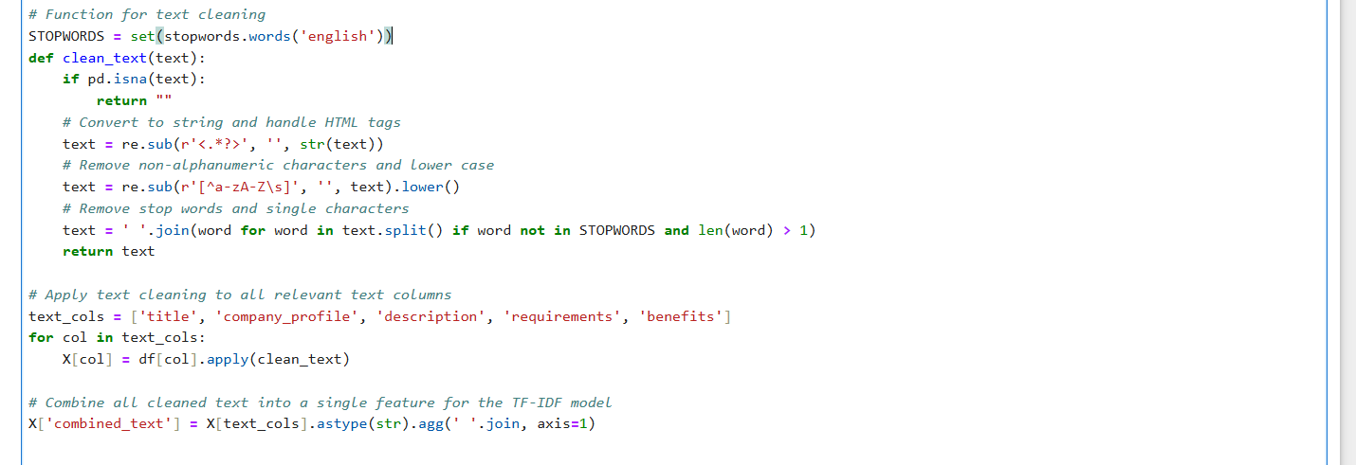
Figure 1: clean_text function

4. Feature Representation

4.1 Text Features
• Represented using TF-IDF Vectorization
• Unigrams and bigrams (ngram_range = (1, 2))
• Vocabulary limited to 10,000 features to control dimensionality

4.2 Categorical Features
• Encoded using One-Hot Encoding
• Unknown categories handled safely (handle_unknown='ignore')

4.3 Binary Features
- Passed directly into the model as numerical inputs

5. Model Selection

5.1 Baseline Model: Logistic Regression
Logistic Regression was initially used as a baseline due to:
- Simplicity and interpretability
- Strong performance on sparse text data
- Fast training time
Class imbalance was addressed using SMOTE during training.

5.2 Final Model: XGBoost Classifier
After experimentation, XGBoost was selected as the final model due to:
- Superior performance on complex, high-dimensional data
- Ability to capture non-linear feature interactions
- Built-in handling of class imbalance via scale_pos_weight
XGBoost consistently achieved a higher F1-score for the fake job class, which was the primary objective.

6. Model Improvements and Enhancements

6.1 Hyperparameter Tuning
• Used RandomizedSearchCV
• Optimized parameters such as:
- n_estimators
- max_depth
- learning_rate
- subsample
- colsample_bytree
• Optimization metric: F1-score (fraud class)

6.2 Probability Calibration
To improve the reliability of predicted probabilities:
- CalibratedClassifierCV with sigmoid calibration was applied
- This ensures that predicted probabilities (e.g., “80% fake”) better reflect true likelihoods
Although calibration slightly reduced raw F1-score, it significantly improved probability trustworthiness, which is critical in fraud detection systems.

6.3 Adjustable Decision Threshold
Instead of a fixed 0.5 threshold:
- A custom threshold is used on P(fake)
- Allows trade-off between:
  - High recall (catch more fake jobs)
  - High precision (reduce false alarms)
This makes the system adaptable to different operational needs.

6.4 Prediction Logging
All predictions are logged to CSV files:
- Timestamp
- Threshold used
- Prediction label
- Probabilities
- Metadata (non-sensitive)
This enables future monitoring, auditing, and model improvement.

7. Deployment Architecture

7.1 Flask REST API
A Flask application (app.py) was developed to:
- Load the trained model once at startup
- Accept job posting data in JSON format
- Apply identical preprocessing steps
- Return:
  - Prediction label
  - Probability of fake and real
  - Threshold used
This API enables easy integration with external systems.

7.2 Streamlit Web Application
An interactive Streamlit interface (streamlit_app.py) was developed to allow users to:
- Enter job posting details manually
- Adjust the fraud detection threshold using a slider
- View prediction results and confidence
- Visualize model reasoning using SHAP Explainability

Explainable AI (SHAP)
- SHAP (SHapley Additive exPlanations) was integrated
- Shows how features contribute to the final decision
- Improves transparency and user trust in predictions

